Linux Assignment
1. Creating and Renaming Files/Directories
1.1 Create a directory named test_dir using mkdir
It is used to create a new directory.
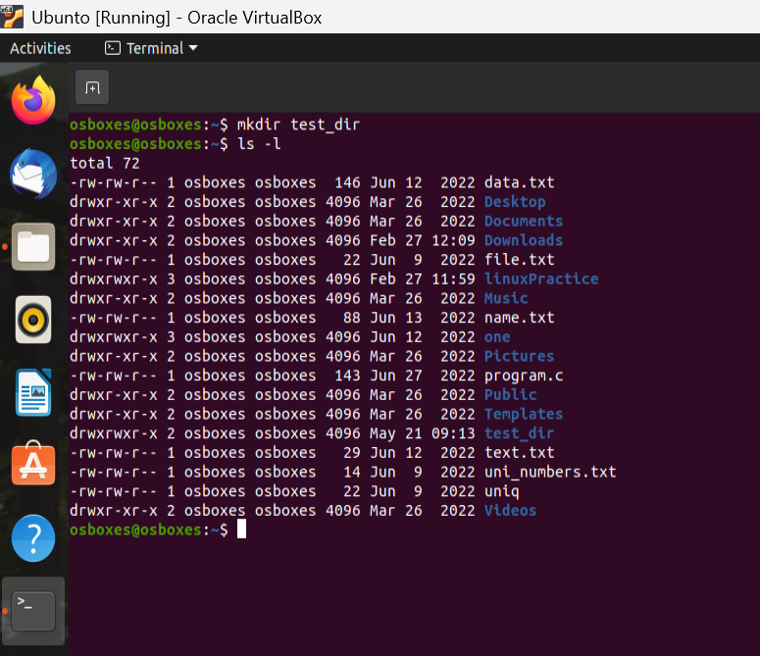

1.2 Inside test_dir, create an empty file called example.txt
Using CD we can move to particular file location.
Using the touch command we can create a new file.
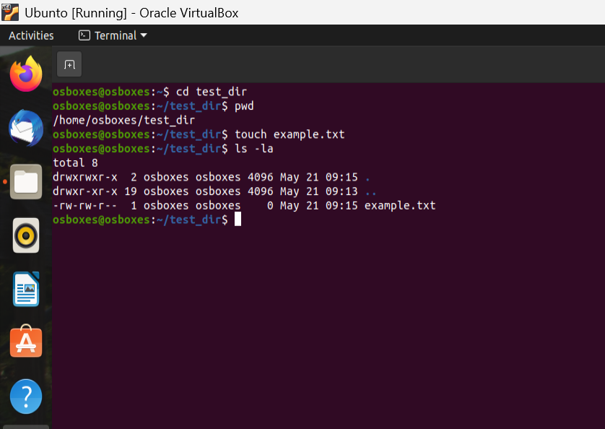
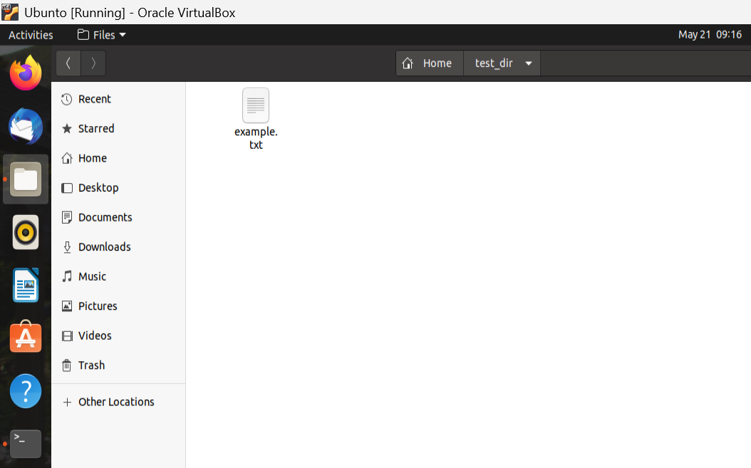

1.3 Rename example.txt to renamed_example.txt using mv
Using the mv command we can move files from one location to another location also we can rename the file using this command.
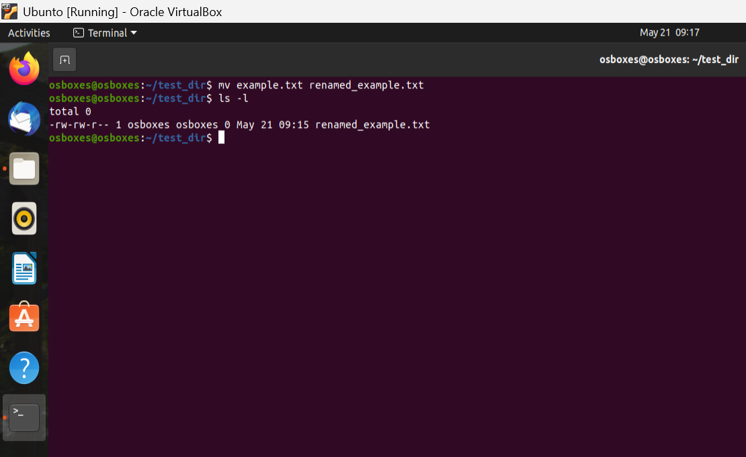
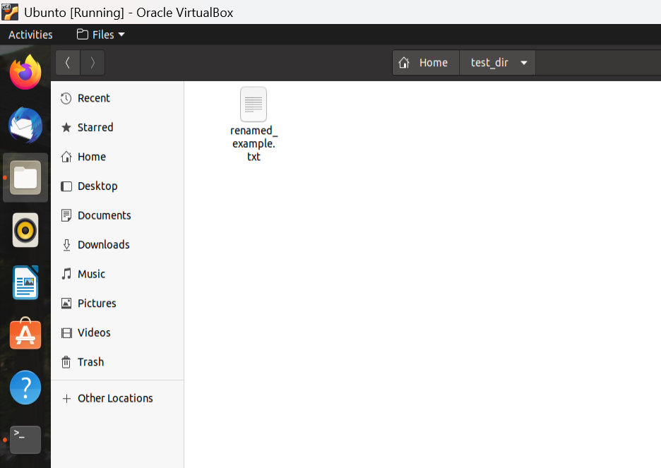

2. Viewing File Contents
2.1 Use cat to display the contents of /etc/passwd.
Using cat command we can see the content of specific file.
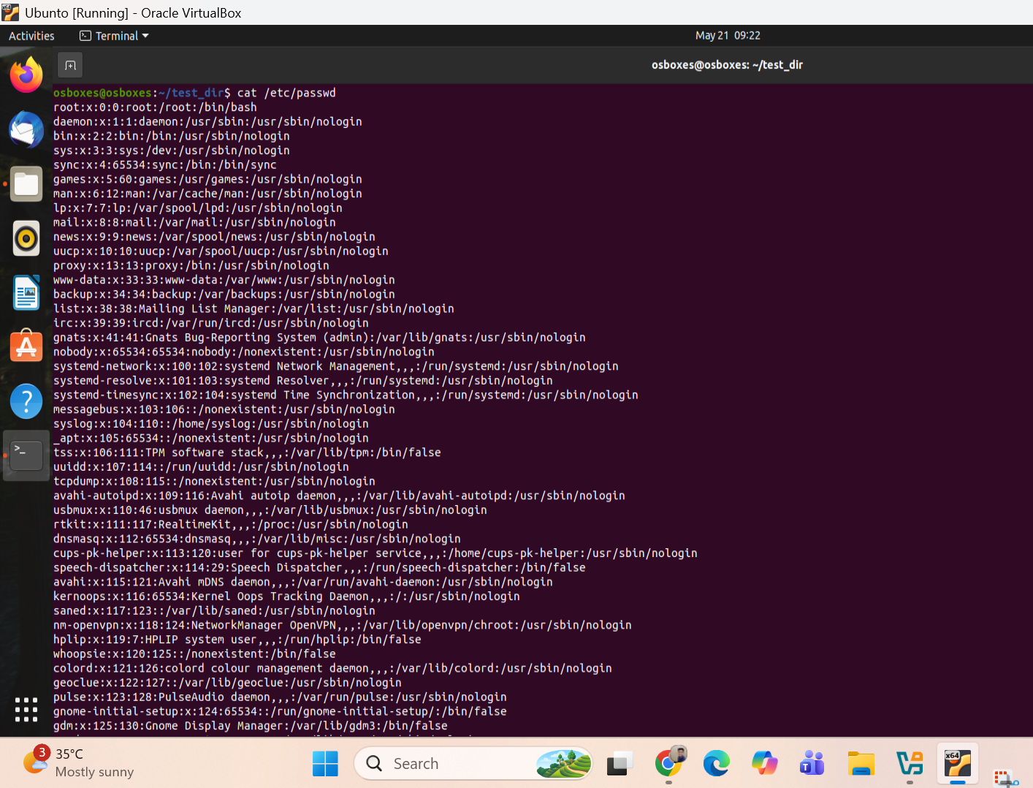

2.2 Display only the first 5 lines of /etc/passwd using head.
2.3 Display only the last 5 lines of /etc/passwd using tail.
Head command is used to see specific content from top of the file. Like in below only first 5 lines are fetched from top.
Tail command is used to see specific content from the bottom of the file. Like in below only the last 5 lines are fetched from bottom.
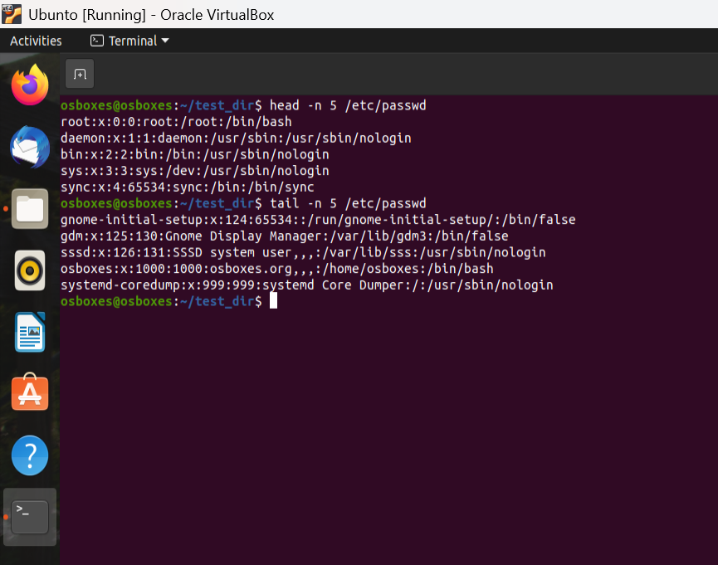

3.Searching for Patterns
Use grep to find all lines containing the word "root" in /etc/passwd.
Grep command is used to search specific content in the file.

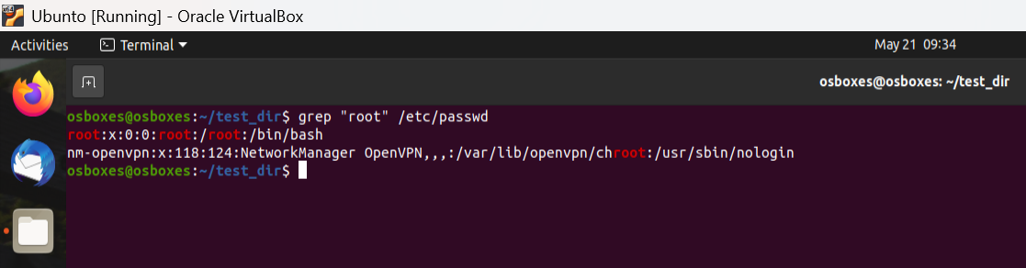

4. Zipping and Unzipping
Compress the test_dir directory into a file named test_dir.zip using zip.
It is used to create zip of the content

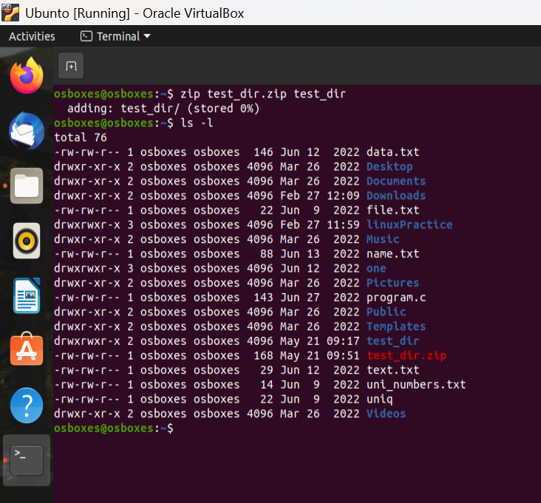
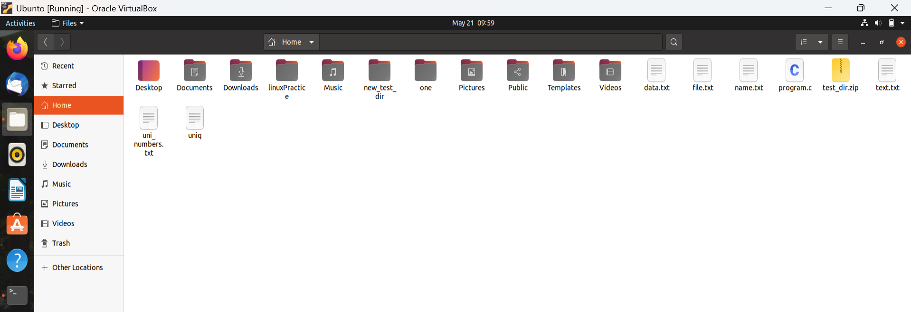

Unzip test_dir.zip into a new directory named unzipped_dir.
It is used to create unzip of the content

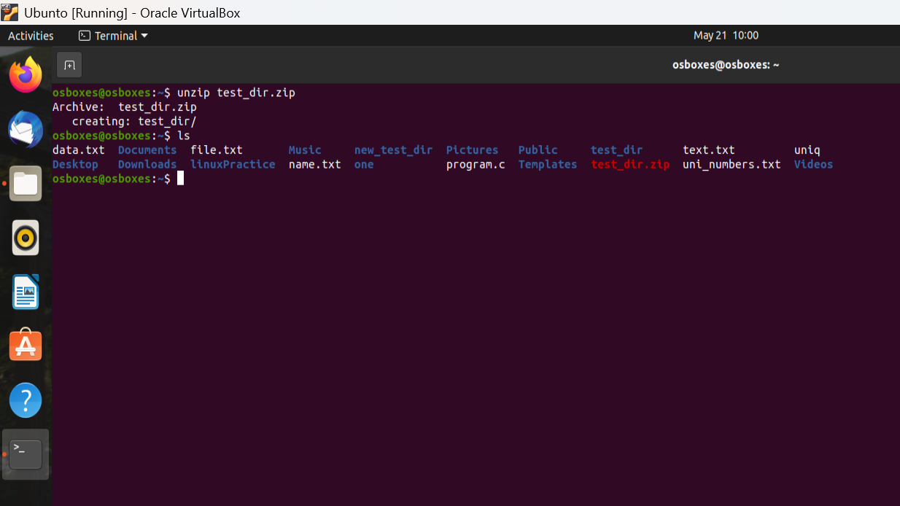
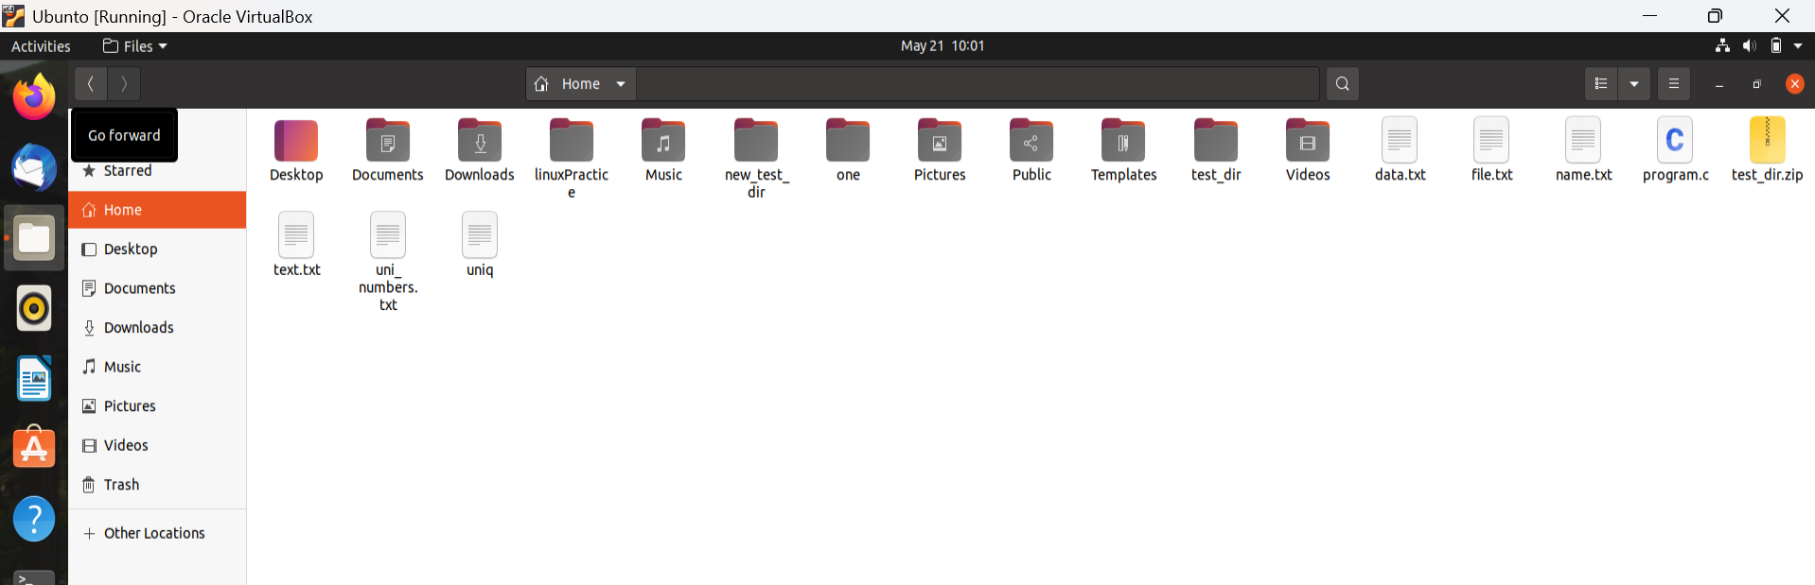

5. Downloading Files
Use wget to download a file
It is used to download content from internet from the specific link/url
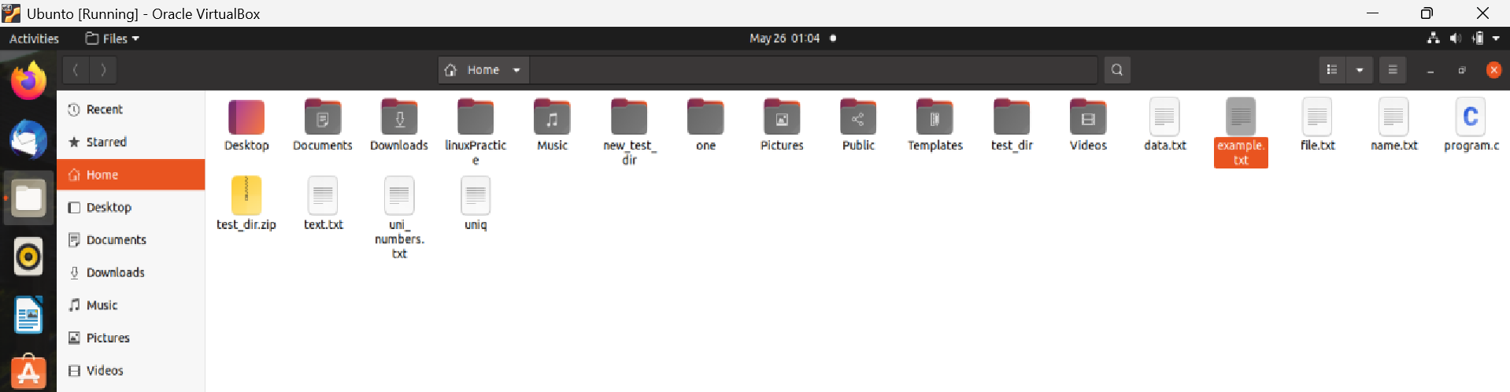
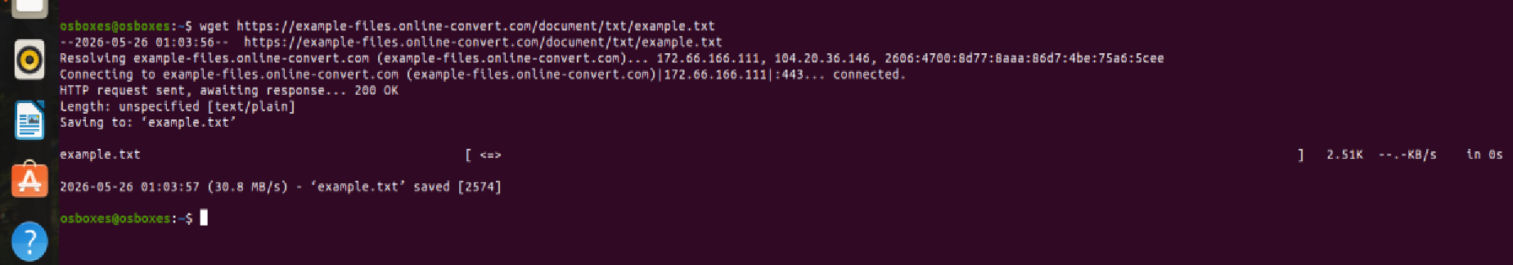

6. Changing Permissions
Create a file named secure.txt and change its permissions to read-only for everyone using chmod.
Chmod is used to assign read write, execute permissions to user groups and others
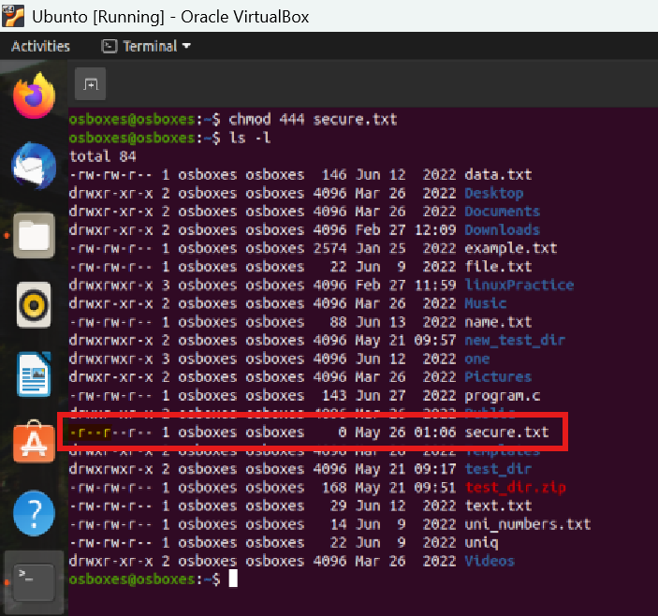

7. Working with Environment Variables
Use export to set a new environment variable called MY_VAR with the value "Hello, Linux!".
It is used to see all environment variables. Also we can set new env variable using export command
